|  |  |  |  |  |  |
| --- | --- | --- | --- | --- | --- |
|  | acc | pre | reca | F1 | Roc |
| logistic regression with degree 2 polynomial kernel | 0.8604 | 0.9652 | 0.8725 | 0.91658 | 0.7106 |
| SVM with RBF Kernel | 0.8619 | 0.9817 | 0.8631 | 0.9186 | 0.69063 |
| SVM with pol kernel | 0.8569 | 0.9813 | 0.8587 | 0.9159 | 0.67916 |
| *random forest classifier* | 0.8864 | 0.9827 | 0.8865 | 0.9321 | 0.74878 |
| *Extreme Gradient boosting classifier* | 0.8799 | 0.9712 | 0.8880 | 0.9277 | 0.74941 |

Light gbm

             precision    recall  f1-score   support

           0       0.92      0.98      0.95      6353

           1       0.91      0.68      0.78      1647

   micro avg       0.92      0.92      0.92      8000

   macro avg       0.92      0.83      0.86      8000

weighted avg       0.92      0.92      0.92      8000

[56]:

<matplotlib.axes._subplots.AxesSubplot at 0x73a88a2ecba8>

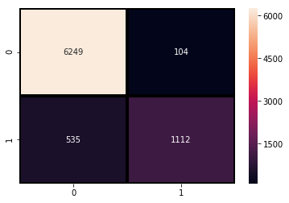

KNN:

             precision    recall  f1-score   support

           0       0.88      0.97      0.92      6353

           1       0.79      0.48      0.60      1647

   micro avg       0.87      0.87      0.87      8000

   macro avg       0.83      0.72      0.76      8000

weighted avg       0.86      0.87      0.85      8000

[57]:

<matplotlib.axes._subplots.AxesSubplot at 0x73a88a75b320>

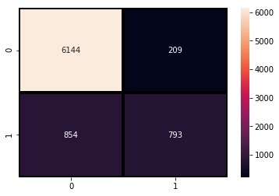

|  |  |  |  |  |  |
| --- | --- | --- | --- | --- | --- |
| Algorithms | Accuracy | Precision | Recall | F1 Score | MCC |
| Logistic regression with degree 2pol kernel | 0.8604 | 0.9652 | 0.8725 | 0.91658 | 0.521 |
| SVM with RBF Kernel | 0.8619 | 0.9817 | 0.8631 | 0.9186 | 0.522 |
| SVM with pol kernel | 0.8569 | 0.9813 | 0.8587 | 0.9159 | 0.50 |
| Random forest classifier | 0.8864 | 0.9827 | 0.8865 | 0.9321 | 0.61 |
| XGBoost | 0.8799 | 0.9712 | 0.8880 | 0.9277 | 0.59 |
| KNN | 0.86 | 0.96 | 0.87 | 0.92 | 0.54 |
| LightGBM | 0.92 | 0.98 | 0.92 | 0.95 | 0.74 |